Model Overview

* 2 separate models, one for lungs and one for airways
  + The loss function I use for image segmentation only works when classes are mutually exclusive, so 2 models are needed when masks overlap
* 64 x 64 x 1 input images (greyscale).
  + Trained on 26*200 images (resampling was allowed)
* 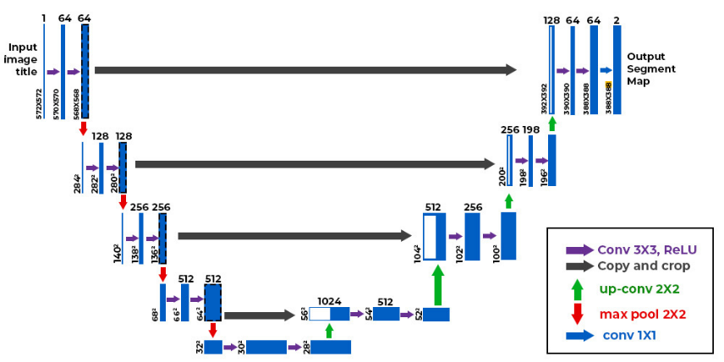U-Net Architecture
* Adam optimizer, learning rate = 0.001
* Batch norm for each layer
* 1 - Dice Coefficient for model loss
  + Per-pixel segmentation accuracy
    - [1-0] (worst) to [1-1] (best)
    - Bigger Dice Coefficient is better
* 5 epochs, 32 batches
  + ~ 1.5 min per epoch on my computer

**Model Test Accuracy (20% split)**

* Lung model Dice coefficient: 0.997
* Airway model Dice coefficient: 0.997

**Image 27 Accuracy**

* Lung model Dice coefficient: 0.618
  + poor accuracy on first images, lowest z-axis values
* Airway model Dice coefficient: 0.064